ASSIGNMENT-03

1.Create a webpage to illustrate types of CSS and types of selectors.

Program:

<!DOCTYPE html>

<html>

<head>

<title>Food</title>

<link type="text/css" href="csss.css" rel="stylesheet">

<STYLE TYPE="TEXT/CSS">

#id1{color:olive;}

.c1{color:#5EA603;}

\*{background-color:lavender;}

H4{border-style:dotted; border-color:blue;}

</STYLE>

</head>

<body>

<h1 style="color:orange;text-align: center">BURGER</h1>

<p>A flat round cake of minced beef that is fried or grilled and typically served in a bread roll; a hamburger.</p>

<P>A hamburger (short: burger) is a sandwich consisting of one or more cooked patties of ground meat, usually beef, placed inside a sliced bread roll or bun. The patty may be pan fried, grilled, or flame broiled. Hamburgers are often served with cheese, lettuce, tomato, onion, pickles, bacon, or chiles; condiments such as ketchup, mayonnaise, mustard, relish, or "special sauce"; and are frequently placed on sesame seed buns. A hamburger topped with cheese is called a cheeseburger. </P>

<H3 id="id1">TYPES OF BURGER</H3>

<H4 class="c1">Beef Burgers</H4>

<P>A traditional ground beef burger can be a good, high-protein meal—especially if it’s grass-finished beef, which we’ll tell you more about in a second. Beef is one of the best sources of B12, a vitamin essential to the production of red blood cells and energy. And even though it’s ranked the worst, that’s largely because of how often beef burgers get totally ruined—it’s hard to find burgers that don’t have descriptors like “double patty,” “onion shoestrings,” and “crispy bacon.”</P>

<H4 class="c1">Elk Burgers</H4>

<P>Elk burger > beef burger. And here’s why: An elk burger not only has more protein than traditional ground beef, but it’s also significantly lower in fat. If you’re chowing down on a 3-ounce burger (you might want to cut your burger in half to keep your portions in check), an elk burger has about 133 calories and 2 grams of fat compared to 182 calories and 9 grams of fat in a beef burger. The lean meat is also tender and high in B12 vitamins and iron, like other meats.</P>

<H4 class="c1">Portobello Mushroom Burgers</H4>

<P>You might be pleasantly surprised by the meaty texture of a portobello mushroom burger. Plus, they have a robust, umami flavor. (Translation: You don’t have to douse it in condiments to trick yourself into thinking you’re enjoying a burger.) But along with allowing you to partake in Meatless Mondays, the polyphenols in mushrooms also elevate them to superstar status. A Penn State study found that portobello and crimini mushrooms rank with carrots, green beans, red peppers, and broccoli as stellar sources of dietary antioxidants.</P>

<H4 >Turkey Burgers</H4>

<P>A great way to keep your turkey burger healthy and on target with your body goals is to eat it with only half a whole-grain bun or put the turkey burger on a bed of lettuce and tomatoes. Regardless, the Nutrition Twins recommend adding lettuce or tomato for the extra nutrients and fiber; plus, the vitamin C in the tomato enhances the absorption of the iron in the turkey. Find out more about The Best Iron Rich Foods—And Why You Need Them, too!</P>

<H4>Veggie Burgers</H4>

<P>Ah, veggie burgers—some really slay while others are just cray. “Traditional veggie burgers are typically satisfying and a great way to slash artery-clogging saturated fat when used to replace hamburgers,” the Nutrition Twins advise. Plus, using veggie burgers reduces exposure to heterocyclic amines, the carcinogens created when meat is heated on the grill at high temperatures.</p>

<H4>Bison Burgers</H4>

<P>Flavor-wise, bison is just about as close as you can get to beef. It’s tender and even a bit sweet. But its nutritional profile makes it a much healthier option than a par-for-the-course ground beef burger. A 90% lean hamburger has about 10 grams of fat, according to the USDA. But a bison burger (AKA buffalo burger), by comparison, has 2 grams of fat and 24 grams of protein—making it a lean, mean protein! Even though it’s not plant-based, bison earned its rank higher up on the list because you can truly satisfy your burger craving with a healthy doppelgänger.</P>

<H4>Wild Salmon Burgers</H4>

<P>A salmon burger could be just what your doctor orders. More specifically, what your cardiologist orders. That’s because, when it comes to proteins, wild salmon is an MVP: It’s rich in omega-3’s, the healthy fatty acids you find in fish oils that can help lower your risk for heart disease and that fend off metabolism-slowing inflammation. In fact, the American Heart Association recommends we eat cold water fatty fish twice a week, but many people fall short of this goal, says Tieraona Low Dog, chief medical officer of Well & Being and director for the first Interprofessional Fellowship in Integrative Health and Medicine. Just make sure it’s always wild salmon.</P>

<H4>Black Bean Burgers</H4>

<P>We’re separating out this subcategory of veggie burgers because black bean burgers are just that worthy of nutritional praise. From a healthy eating standpoint, they’ve got everything you’d want in a burger: Black beans pack 8 grams of protein and 7.5 grams of fiber in a 1/2-cup serving, but they’re low in calories and free of saturated fat.</P>

</body>

</html>

CSS External:

h4{color:#5EA603 ;}

OUTPUT:

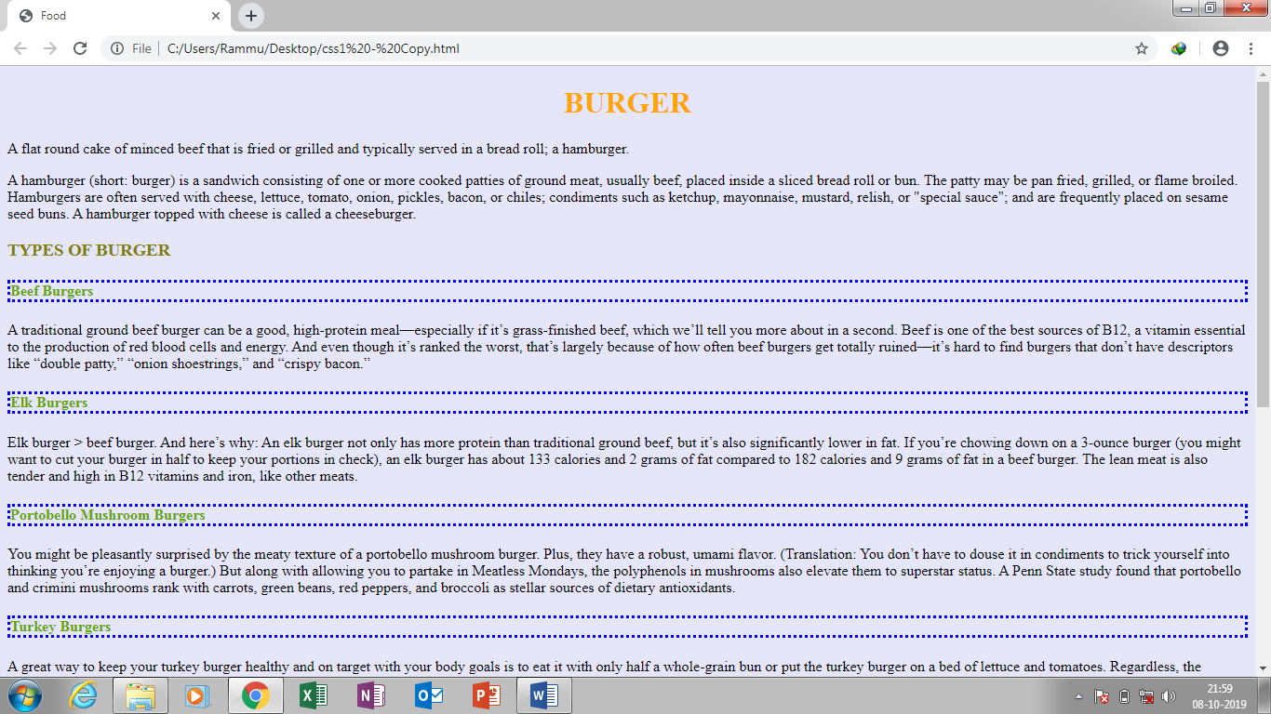

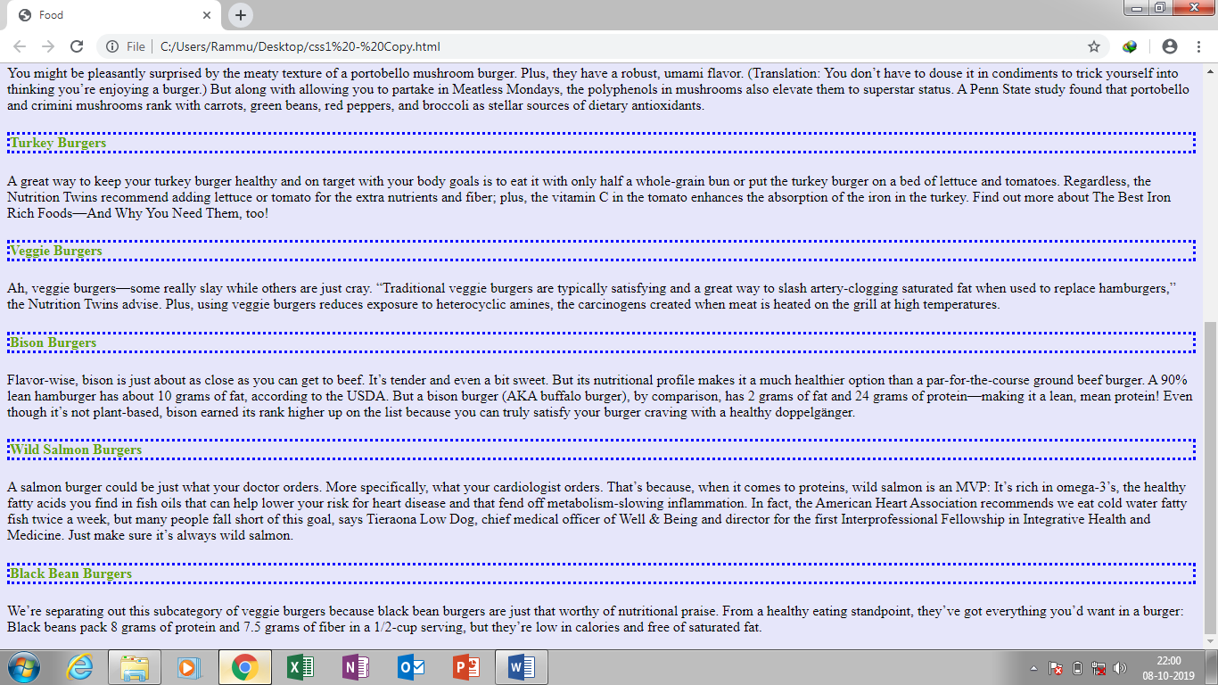

2. Create a webpage using following CSS properties :

a.CSS Border b.CSS Background c.CSS Text d.CSS Font e.CSS Margin f.CSS Padding

<!DOCTYPE html>

<html>

<head>

<title>Eiffel Tower</title>

<style type="text/css">

#id1{background-color: pink;border-style: dashed;text-align: justify;font-size: 18px;margin: 18px;padding: 5px;}

.c1{background-color:pink;text-align: justify;font-size: 17px;margin: 15px;padding: 8px}

h3{border-style:groove;}

BODY{background:url(i1.jpeg) no-repeat center center fixed;}

</style>

</head>

<body>

<h3>Eiffel Tower</h3>

<P id="id1">The Eiffel Tower is a wrought-iron lattice tower on the Champ de Mars in Paris, France. It is named after the engineer Gustave Eiffel, whose company designed and built the tower.Constructed from 1887 to 1889 as the entrance to the 1889 World's Fair, it was initially criticised by some of France's leading artists and intellectuals for its design, but it has become a global cultural icon of France and one of the most recognisable structures in the world.[3] The Eiffel Tower is the most-visited paid monument in the world; 6.91 million people ascended it in 2015.The tower is 324 metres (1,063 ft) tall, about the same height as an 81-storey building, and the tallest structure in Paris. Its base is square, measuring 125 metres (410 ft) on each side. During its construction, the Eiffel Tower surpassed the Washington Monument to become the tallest man-made structure in the world, a title it held for 41 years until the Chrysler Building in New York City was finished in 1930. It was the first structure to reach a height of 300 metres. Due to the addition of a broadcasting aerial at the top of the tower in 1957, it is now taller than the Chrysler Building by 5.2 metres (17 ft).Excluding transmitters, the Eiffel Tower is the second tallest free-standing structure in France after the Millau Viaduct.</P>

<h3>Origin</h3>

<p class="c1">The design of the Eiffel Tower is attributed to Maurice Koechlin and Émile Nouguier, two senior engineers working for the Compagnie des Établissements Eiffel. It was envisioned after discussion about a suitable centrepiece for the proposed 1889 Exposition Universelle, a world's fair to celebrate the centennial of the French Revolution. Eiffel openly acknowledged that inspiration for a tower came from the Latting Observatory built in New York City in 1853.[4] In May 1884, working at home, Koechlin made a sketch of their idea, described by him as "a great pylon, consisting of four lattice girders standing apart at the base and coming together at the top, joined together by metal trusses at regular intervals".[5] Eiffel initially showed little enthusiasm, but he did approve further study, and the two engineers then asked Stephen Sauvestre, the head of company's architectural department, to contribute to the design. Sauvestre added decorative arches to the base of the tower, a glass pavilion to the first level, and other embellishments.</p>

</body>

</html>

OUTPUT:

